Vine Academy
2015– 2016

Set-up and Use of GradeKeeper

Detailed Instructions for the Set-up and Use of GradeKeeper

Download the latest version of GradeKeeper at www.gradekeeper.com
If you are asked, our account information is: Name: Vine Academy, Code: 672548
Step 1. Set up your Gradebook Options.
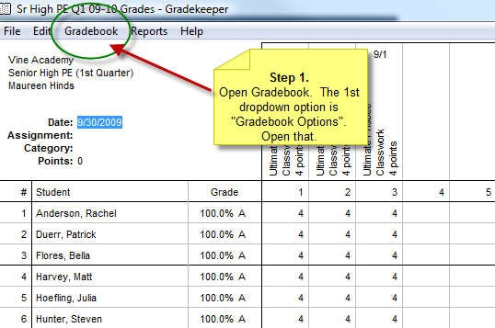

(continued next page)
Step 2. Set up the calendar in the “School Year” tab. (Enter 2011/12 dates) 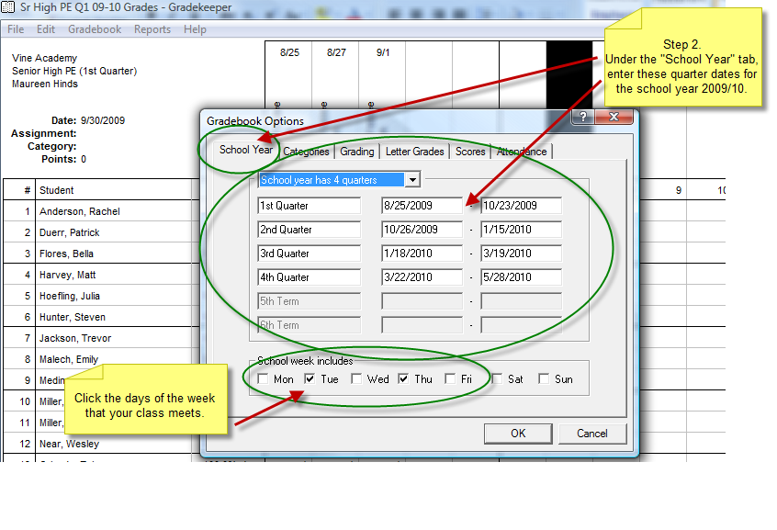

Step 3. In the “Categories” tab, enter your own categories and the percentages they will be worth. Vine allows each teacher to set their own categories and percentage weights.
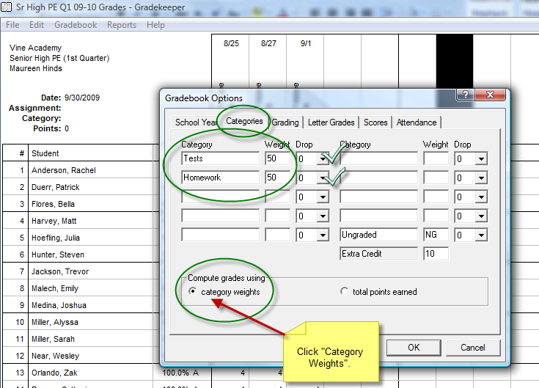

Step 4. Leave the information in the “Grading” tab as the default set.
Step 5. Set up the “Letter Grades” tab. Unless you have prior permission from Vine to change the Letter Grading System, these are the grades you must use. Note – Vine does not award A+, so the first and 2nd grades both should say “A”. This is the only information you should need to change in this tab.

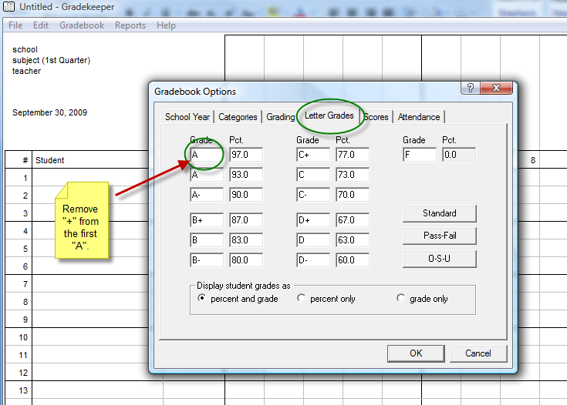

Step 6. Leave the information in the “Scores” and “Attendance” tabs the default. Click “ok” to close the “Gradebook Options”.

Steps 7. Set up your personal class information.

Step 8 : You will enter the assignments as the year progresses.

Step 9: Enter your students names exactly as they are written on the class list. This is very important, as reports cards need to be the same from all teachers so gradekeeper can collate each students grade.

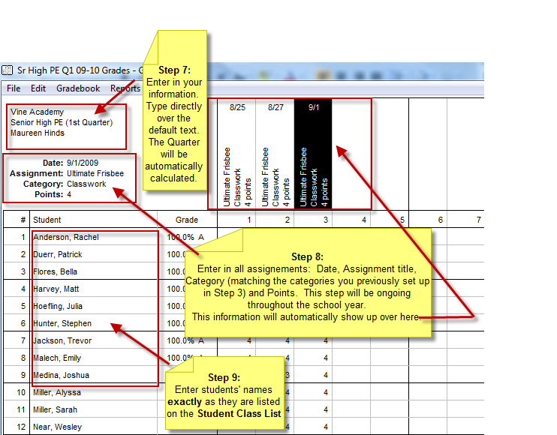

Note: As each assignment is graded, type in each student’s score under each assignment listed. The column labeled “Grade” will automatically calculate by the scores you enter for each assignment.

Under File, click “Save As” and title your file. Note where in your directory it is saved for future reference.

Step 10. Setting up to send grades for report cards:
You will need to call your internet provider for the following information.
SMTP Server address and SMTP Server port number.

Once you have that information go to Edit on the tool bar, click on “Edit Email Server” Enter the following:
a.Teacher email address: your address
b. SMTP server address: Enter the SMTP Server address & Server Port
c. SMTP Username: Enter in your email again, and your own password

Click on “OK”

Step 11. So that you may send students’ parents progress reports through e-mail, you need to enter their e-mail address. Go to Edit, click on edit email addresses.
Entering email addresses – enter the following:
- In the first field: the first student from your gradebook should automatically appear.
- In recipients enter the parent’s email for that student.

c. Next, go back to the student name field, click on the drop down arrow and highlight the next student and his/her parent’s email address in the recipients box.

Once you have done these steps for each student, click “done”.

Congratulations, your Gradekeeper set-up is complete.

Sending Progress Reports
- Click on File, click on “Email Student Scores”. A window will pop up saying, “this will email progress reports to every student in this class”. Click “OK”.
- A window should pop up saying the report is being sent and voila: Your progress reports have been sent! Could it be any easier? Please send reports to students’ parents and send a class summary (all of your students’ current grades on one page) to the Dean of Instruction, Karen Wells, at upwardflight@live.com.

Sending Quarterly and Semester Grades
(Same process as Progress Reports, just done at the end of each quarter with one additional step.)
- Click on File, click on “Email Student Scores”. A window will pop up saying, “this will email progress reports to every student in this class”. Click “OK”.
- A window should pop up saying the report is being sent and voila!! Your Quarter grades have been sent! Could it be any easier? Please send reports to students’ parents.
- One additional step to be done for quarter grades: compose an email to Karen Wells at upwardflight@live.com. Submit your completed quarter grades by attaching your Gradekeeper file to the email, specific to each class, then sending it. Be sure and make note of where you have saved the file on your computer so you can find it easily each quarter.

Other Tidbits of Information

- If you want to send other reports like Student Summary, Student Missing Assignment or Attendance, please follow the same steps as sending Student Scores except choose the other sending report options (i.e. “Email Student Summary”.) The Student Summary report gives a detailed breakdown of each assignment, (“points available” and “points earned by student.”) Use the other reports at your own discretion or the request of your department head.

- One final note: please be sure to require parents to sign and return Progress Reports of students that are receiving a quarterly grade lower than 73%. It is also recommended that you ask all parents to acknowledge the receipt of all emailed reports.

